TCS3200 (COLOUR SENSOR)

TCS3200 is a color sensor which can detect any number of colors with right programming. TCS3200 contains RGB (Red Green Blue) arrays. On microscopic level we can see some square boxes in the middle the sensor. These square boxes are arrays of photodiodes of RGB matrix.

**PIN CONFIGURATION**

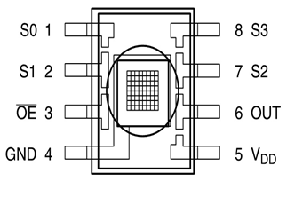

Each of sensor arrays in these three arrays are selected separately depending on requirement. Hence it is known as **programmable sensor**. The module can be featured to sense the particular color and to leave the others. It contains filters for that selection purpose. There is forth mode that is no filter mode. With no filter mode the sensor detects white light.

**WORKING**

The color which needs to be sensed by the color sensor is selected by two pins S2 and S3. With these two pins logic control we can tell sensor which color light intensity is to be measured.

Say we need to sense the RED color intensity we need to set both pins to LOW. Once that is done the sensor detects the intensity and sends the value to the control system inside the module.

|  |  |  |
| --- | --- | --- |
| **S2** | **S3** | **Photodiode Type** |
| L | L | Red |
| L | H | Blue |
| H | L | Clear (no filter) |
| H | H | Green |

 The light intensity measured by array is sent to current to frequency converter. What it does is, it puts out a square wave whose frequency is in relation to current sent by ARRAY.

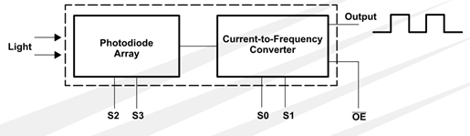

The signal frequency sent by module can be modulated depending on use. We can change the output signal frequency bandwidth.

|  |  |  |
| --- | --- | --- |
| **S0** | **S1** | **Output Frequency Scaling (f0)** |
| L | L | Power Down |
| L | H | 2% |
| H | L | 20% |
| H | H | 100% |
|  |  |  |

**PROBLEMS FACED and SOLUTION**

**When I used the pulseIn function for output from the sensor , I got various wrong and garbage values. This problem mostly arises due to improper shielding of the sensor. It should be shielded by thermocol kind thing which should be hollow and put the sensor inside the thermocol. Then properly cover the interior of the thermocol with a black insulation tape with two or three layers. This would avoid the problem of garbage values.**

**Even after shielding the output from the sensor is zero or any garbage value then use this in the arduino code.**

* **Serial.print(red, DEC); #Here red is the output we are getting from the pulseIn function**

-Now set the conditions according to the values you are getting on the serial monitor.